Project Title
Hospital Equipment Management System Using PostgreSQL

Project Description
This project focuses on designing and analyzing a hospital equipment management database using PostgreSQL. The database stores patient information, department details, admission records, vital signs, equipment usage, hospital stay duration, and treatment costs. SQL queries were executed through pgAdmin 4, the graphical administration tool for PostgreSQL, to retrieve meaningful business insights and support efficient hospital data management.

Software Used
- Database: PostgreSQL
- Database Administration Tool: pgAdmin 4
- Query Language: SQL

How many patients are admitted to the hospital?
Calculates the total number of patients admitted to the hospital.
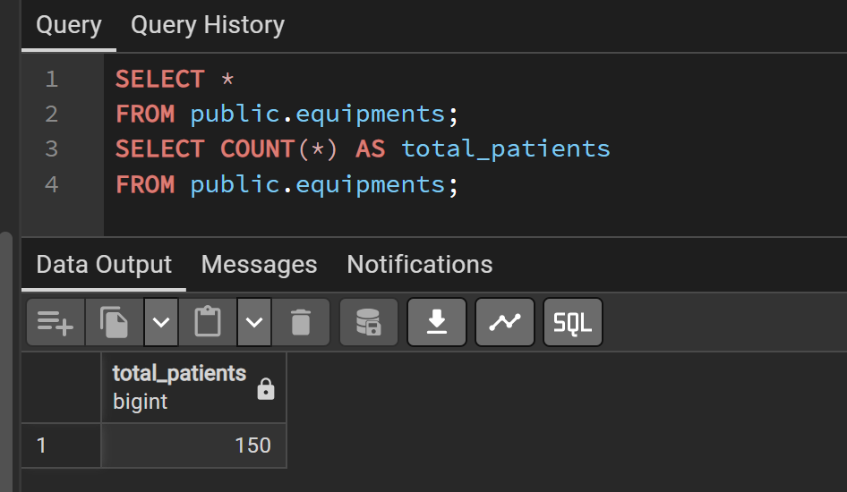
- What is the average age of all admitted patients?
Determines the average age of all admitted patients.
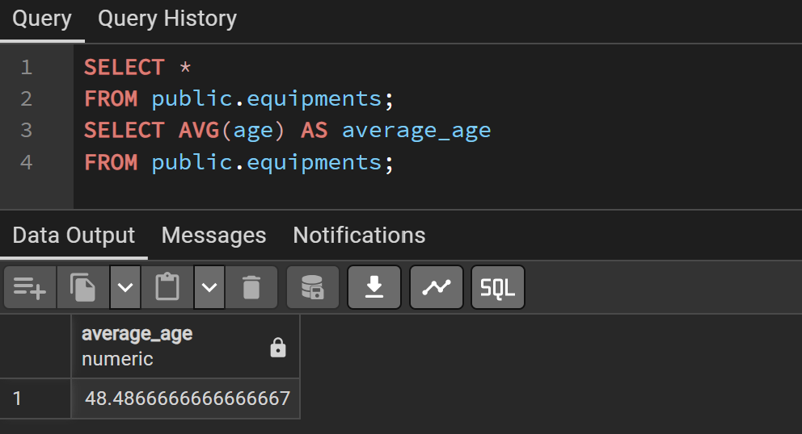
- Which department has the highest number of patient admissions?
Identifies the department with the maximum patient admissions.
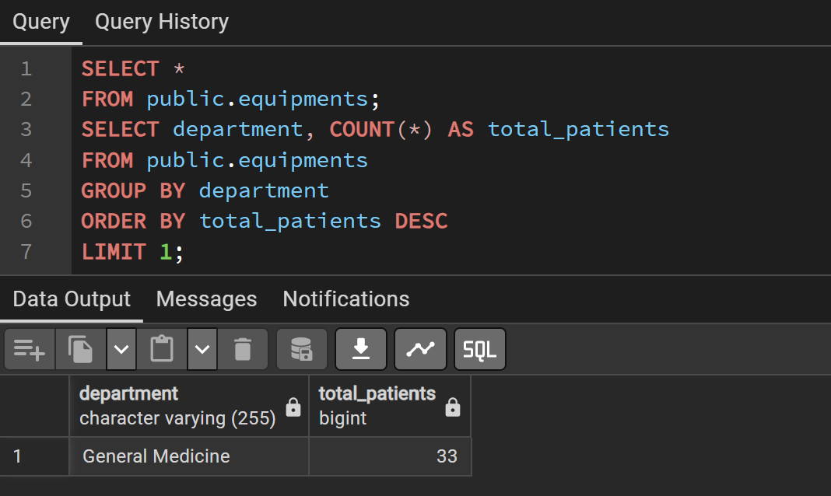
- Which department has the lowest number of patient admissions?
Finds the department with the fewest patient admissions.
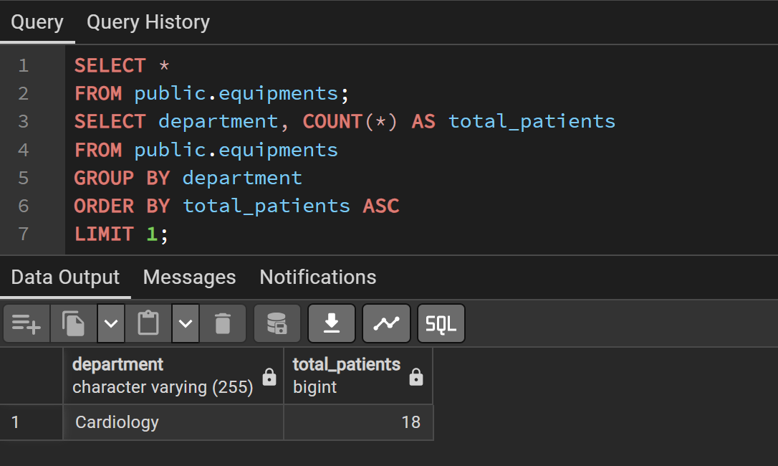
- How many patients are admitted to each department?
Displays the patient count for every hospital department.
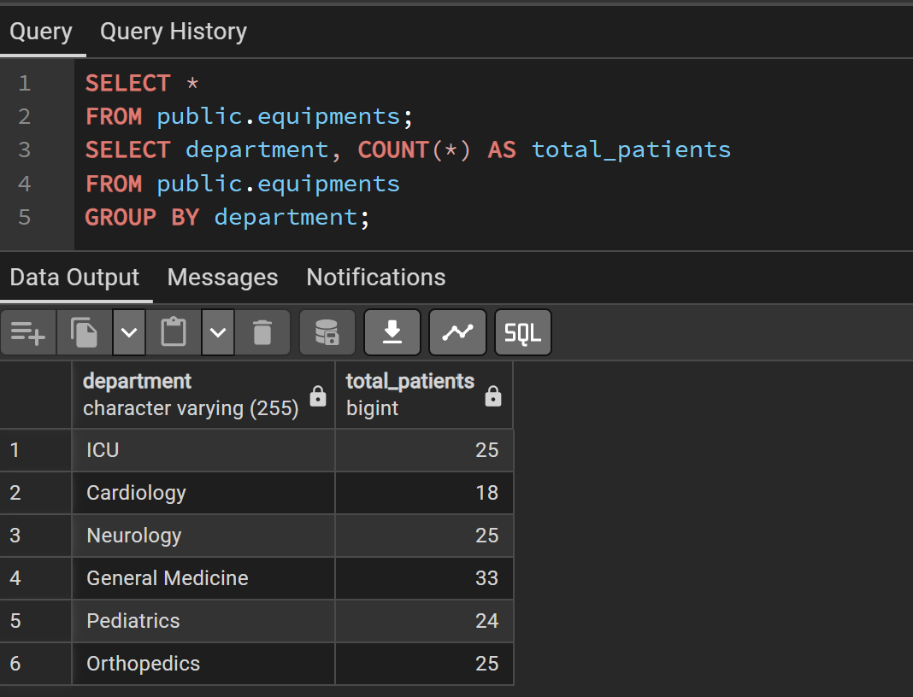
- Which patient is the oldest?
Retrieves the details of the oldest admitted patient.
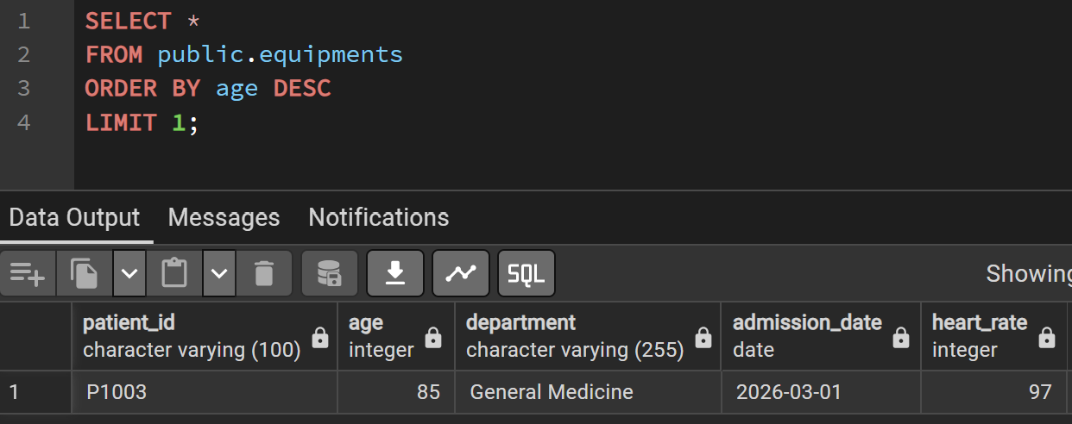
- Which patient is the youngest?
Retrieves the details of the youngest admitted patient.
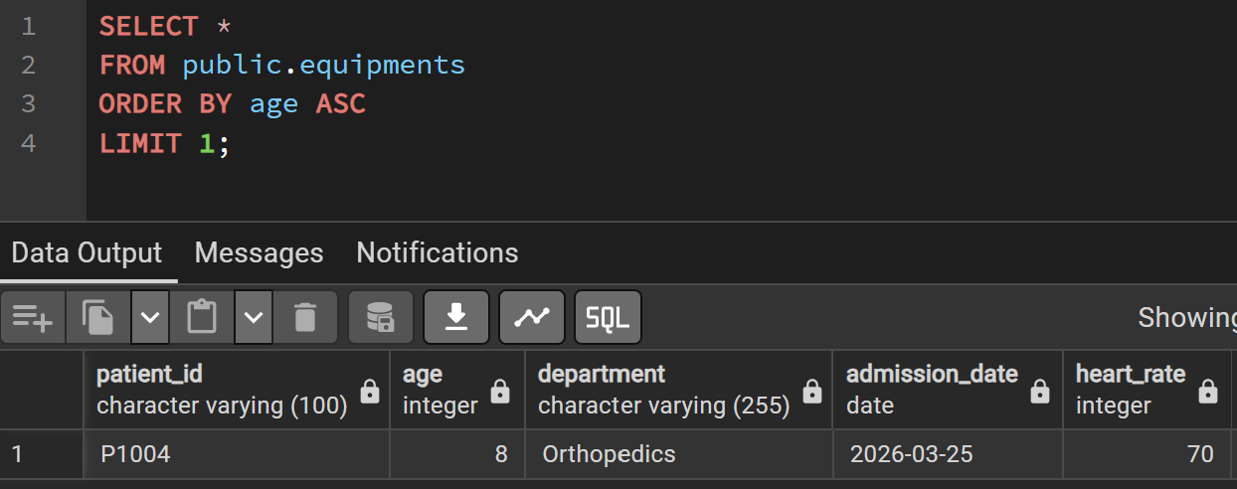
- How many patients are above 60 years of age?
Counts the number of senior patients aged above 60 years.
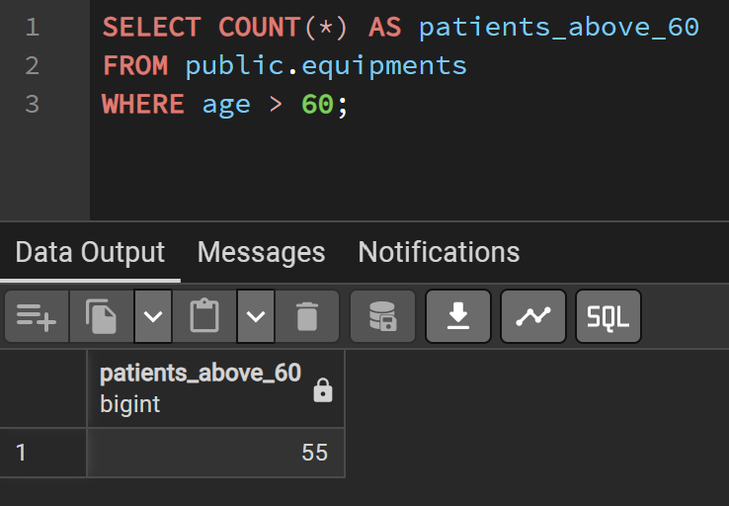
- What is the average heart rate of all patients?
Calculates the average heart rate across all patients.
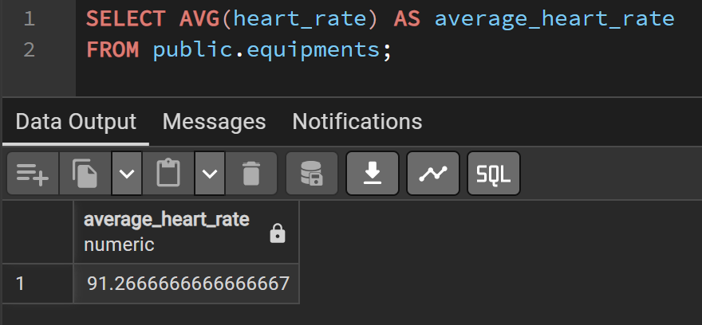
- Which patient has the highest heart rate?
Identifies the patient with the maximum recorded heart rate.
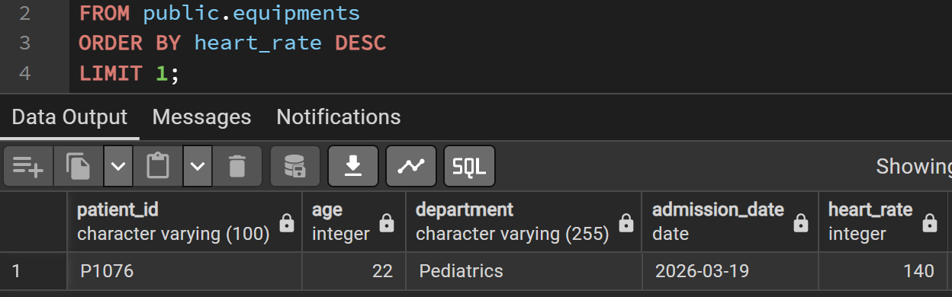
- Which patient has the lowest heart rate?
Identifies the patient with the minimum recorded heart rate.
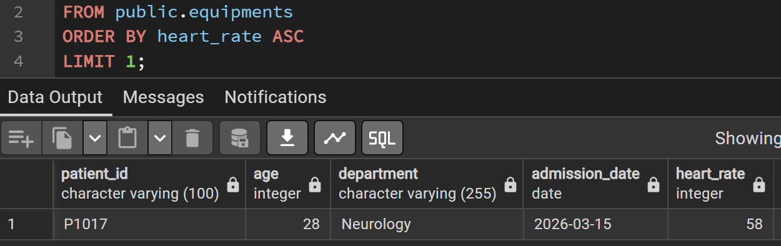
- How many patients have high systolic blood pressure (≥140 mmHg)?
Counts patients diagnosed with high systolic blood pressure.
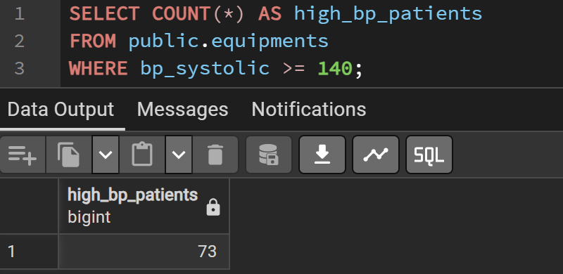
- How many patients have low oxygen saturation (<95%)?

Counts patients with oxygen saturation below the normal level.
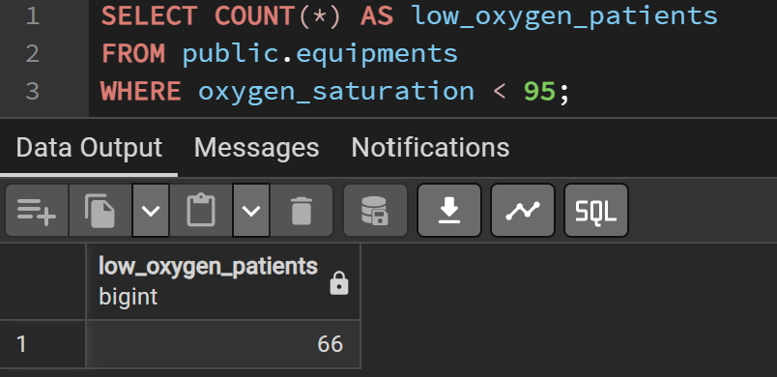
- What is the average oxygen saturation of all patients?
Computes the average oxygen saturation of admitted patients.
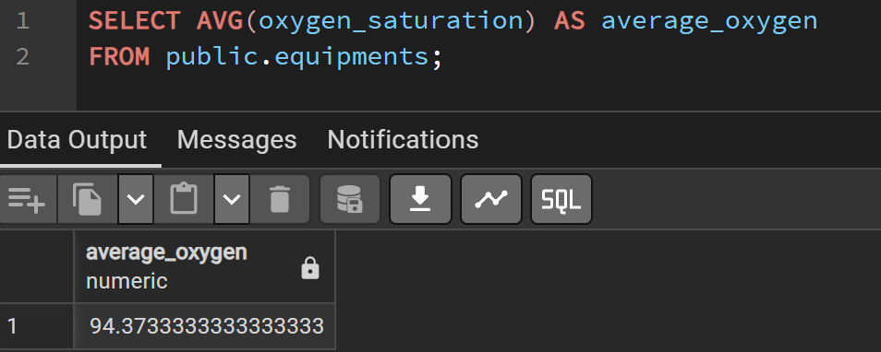
- Which department has the highest average heart rate?
Determines the department with the highest average heart rate.
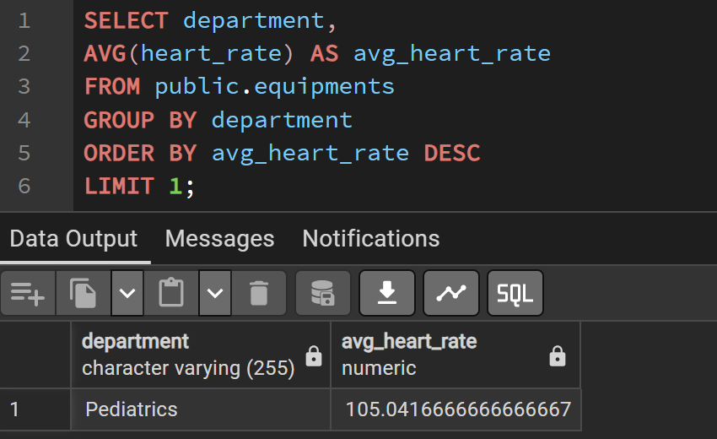
- Which department has the highest average treatment cost?
Identifies the department with the highest average treatment expenses.
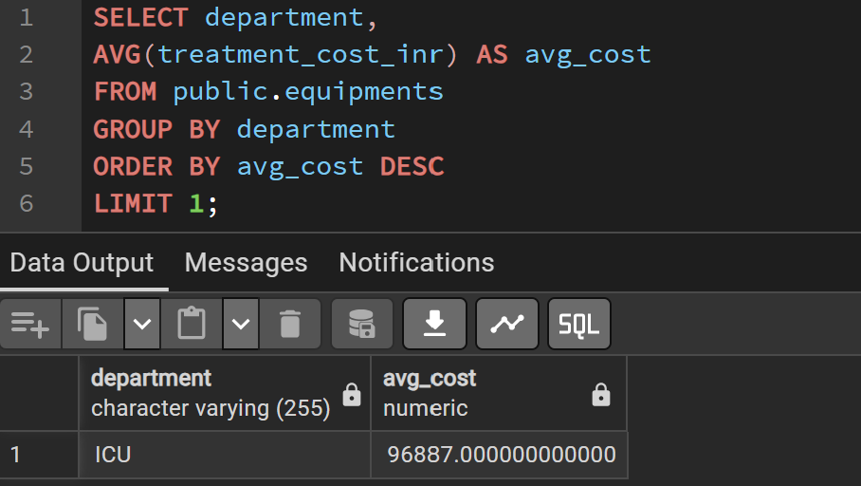
- What is the average treatment cost for each department?
Calculates the average treatment cost department-wise.
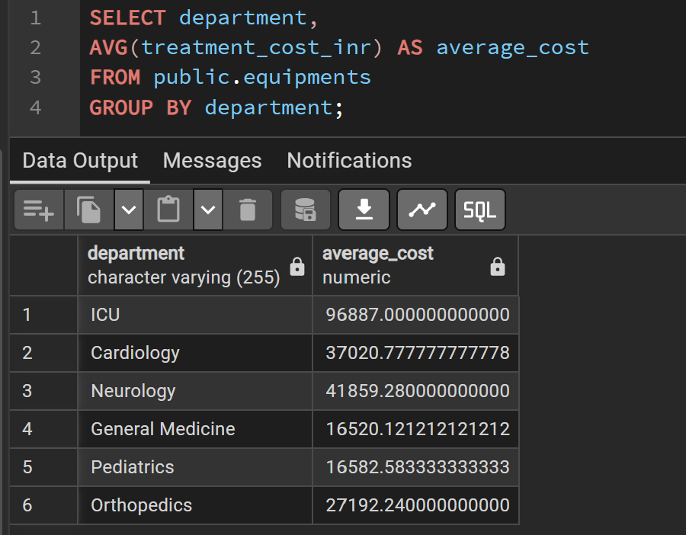
- Which patient has the highest treatment cost?
Finds the patient with the highest treatment cost.
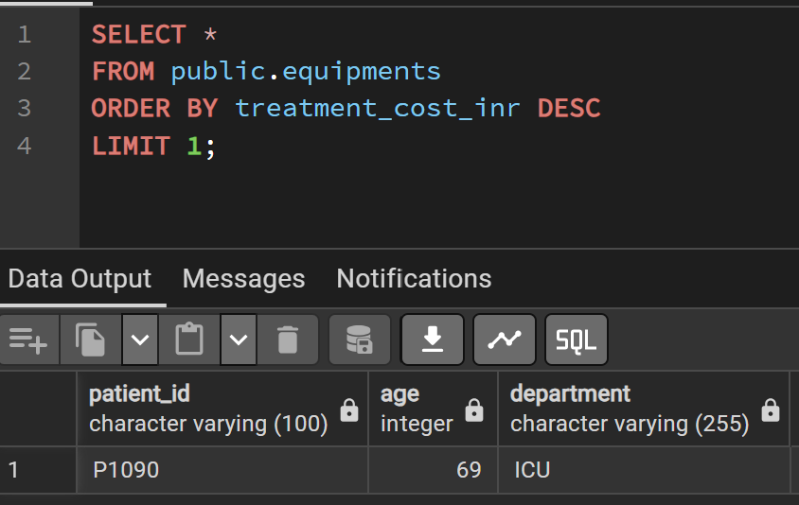
- Which patient has the lowest treatment cost?
Finds the patient with the lowest treatment cost.
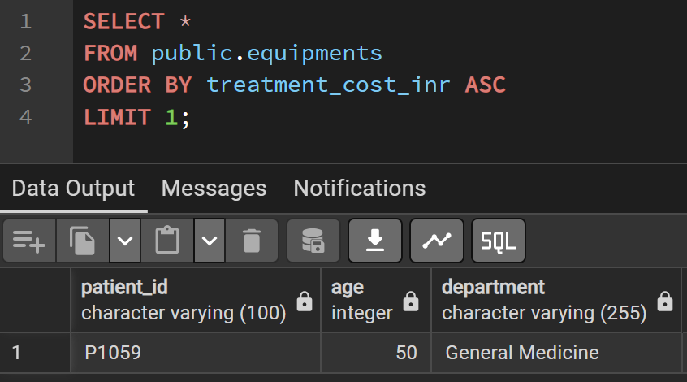
- Which medical equipment is used most frequently?
Identifies the most frequently used medical equipment.
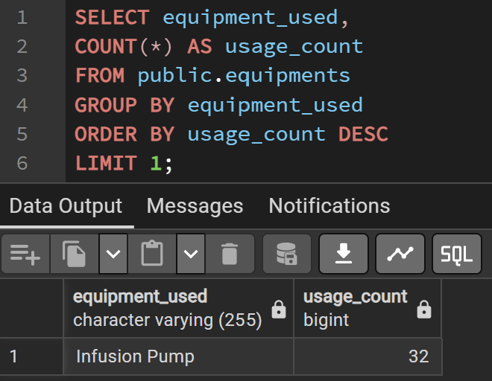
- How many patients use each type of medical equipment?
Counts the number of patients using each type of equipment.
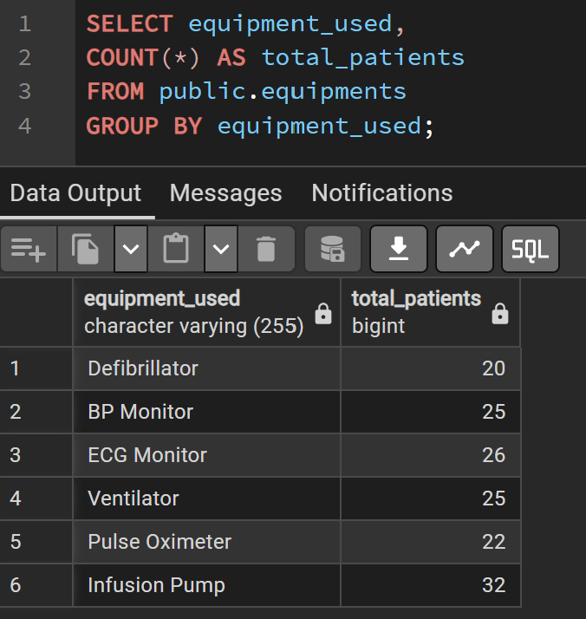
- Which department uses the most medical equipment?
Determines the department with the highest equipment utilization.
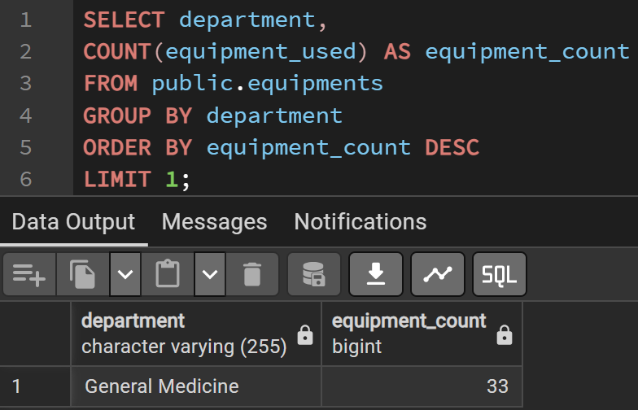
- What is the average length of hospital stay?
Calculates the average duration of patient hospitalization.
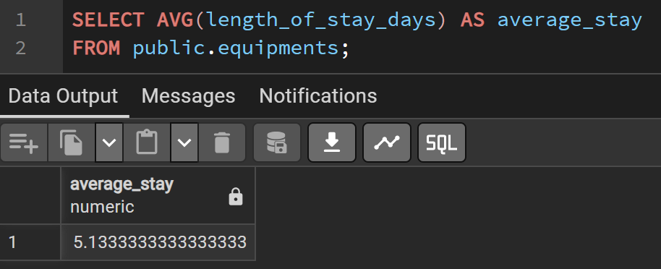
- Which patient has the longest hospital stay?
Identifies the patient with the longest hospital stay.
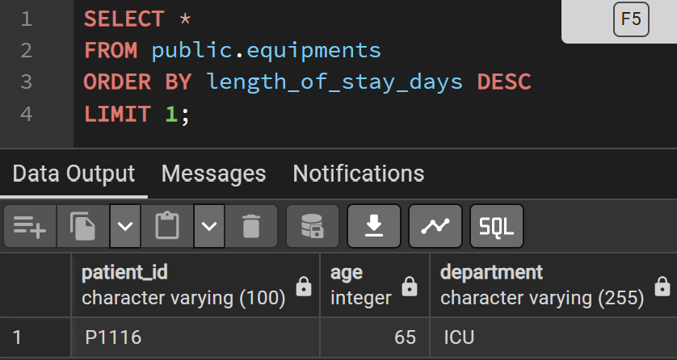
- Which department has the longest average patient stay?
Finds the department where patients stay the longest on average.
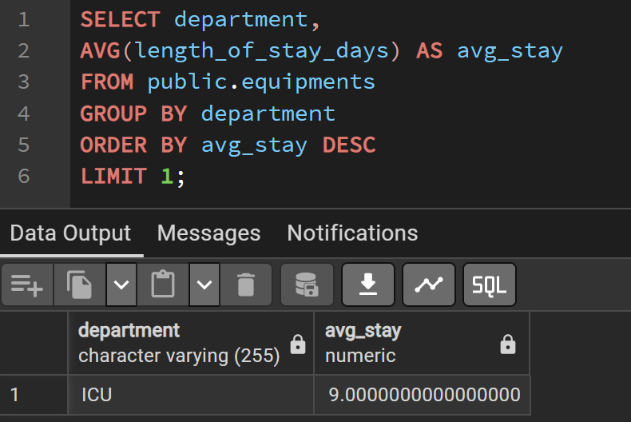
- How many patients were admitted on March 15?
Counts patients admitted after the specified admission date.
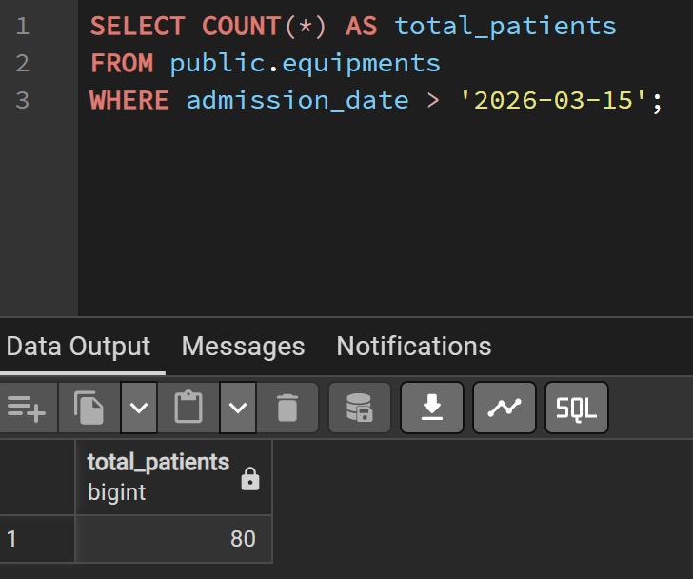
- Which patients have abnormal vital signs (high heart rate, high blood pressure, or low oxygen saturation)?
Identifies patients with abnormal heart rate, blood pressure, or oxygen saturation.
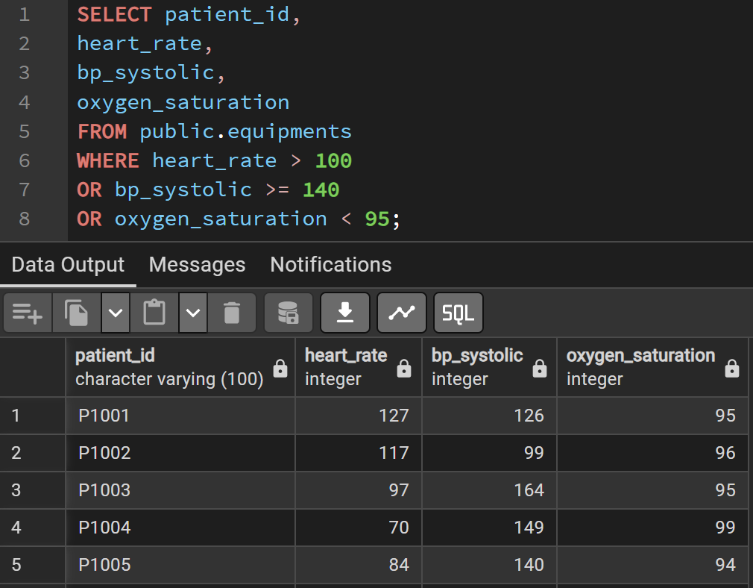
- Which patients have treatment costs higher than the hospital's average treatment cost?
Lists patients whose treatment costs exceed the hospital average.
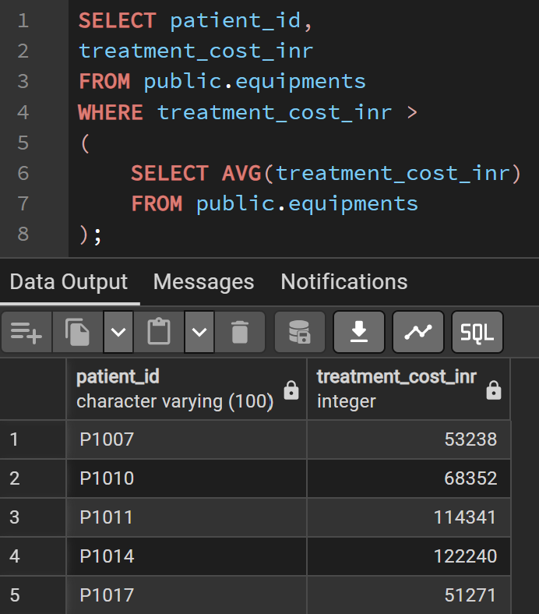
- What are the top five patients with the highest treatment costs?
Displays the top five patients with the highest treatment expenses.
